Participial Attribute

✅ What is Participial Attribute?
# Source: AI Source: Provided by: [Data Path: Persons Table -> ID Column: 1, Name_En Column: Motasem Essam] -> From: [Chatgpt (GPT‑5 Mini)] on [8/7/2025]
A Participial Attribute is a present or past participle (or participial phrase) that modifies a noun directly, functioning as an adjective. It provides descriptive information about the noun it modifies.

🔹 Types of Participial Attributes:
# Source: AI Source: Provided by: [Data Path: Persons Table -> ID Column: 1, Name_En Column: Motasem Essam] -> From: [Chatgpt (GPT‑5 Mini)] on [8/7/2025]
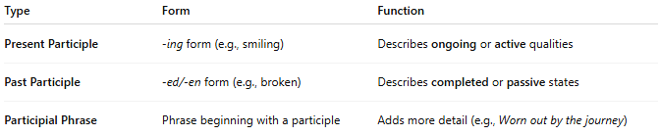
Type | Form | Function
Present Participle | -ing form (e.g., smiling) | Describes ongoing or active qualities
Past Participle | -ed/-en form (e.g., broken) | Describes completed or passive states
Participial Phrase | Phrase beginning with a participle | Adds more detail (e.g., Worn out by the journey)

🔹 Key Features:
# Source: AI Source: Provided by: [Data Path: Persons Table -> ID Column: 1, Name_En Column: Motasem Essam] -> From: [Chatgpt (GPT‑5 Mini)] on [8/7/2025]
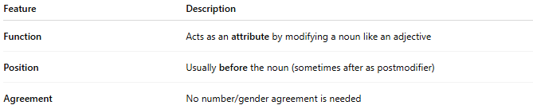
Feature | Description
Function | Acts as an attribute by modifying a noun like an adjective
Position | Usually before the noun (sometimes after as postmodifier)
Agreement | No number/gender agreement is needed

🔹 Examples in Sentences:
# Source: AI Source: Provided by: [Data Path: Persons Table -> ID Column: 1, Name_En Column: Motasem Essam] -> From: [Chatgpt (GPT‑5 Mini)] on [8/7/2025]
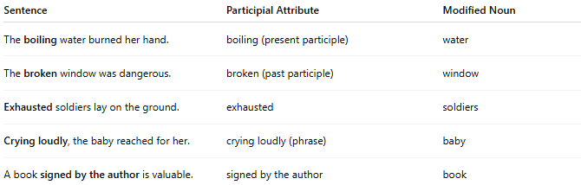
Sentence | Participial Attribute | Modified Noun
The boiling water burned her hand. | boiling (present participle) | water
The broken window was dangerous. | broken (past participle) | window
Exhausted soldiers lay on the ground. | exhausted | soldiers
Crying loudly, the baby reached for her. | crying loudly (phrase) | baby
A book signed by the author is valuable. | signed by the author | book

🔹 Common Usage Tips:
# Source: AI Source: Provided by: [Data Path: Persons Table -> ID Column: 1, Name_En Column: Motasem Essam] -> From: [Chatgpt (GPT‑5 Mini)] on [8/7/2025]
- Use present participle for active meaning: The running man.
- Use past participle for passive meaning: The abandoned house.
- Participial phrases often appear in literary or formal writing.

